**EXPERIMENT 1**

FLIGHT RESERVATION SYSTEM

STEP -1: Go to the Zoho Creator and build the app for Flight Reservation System

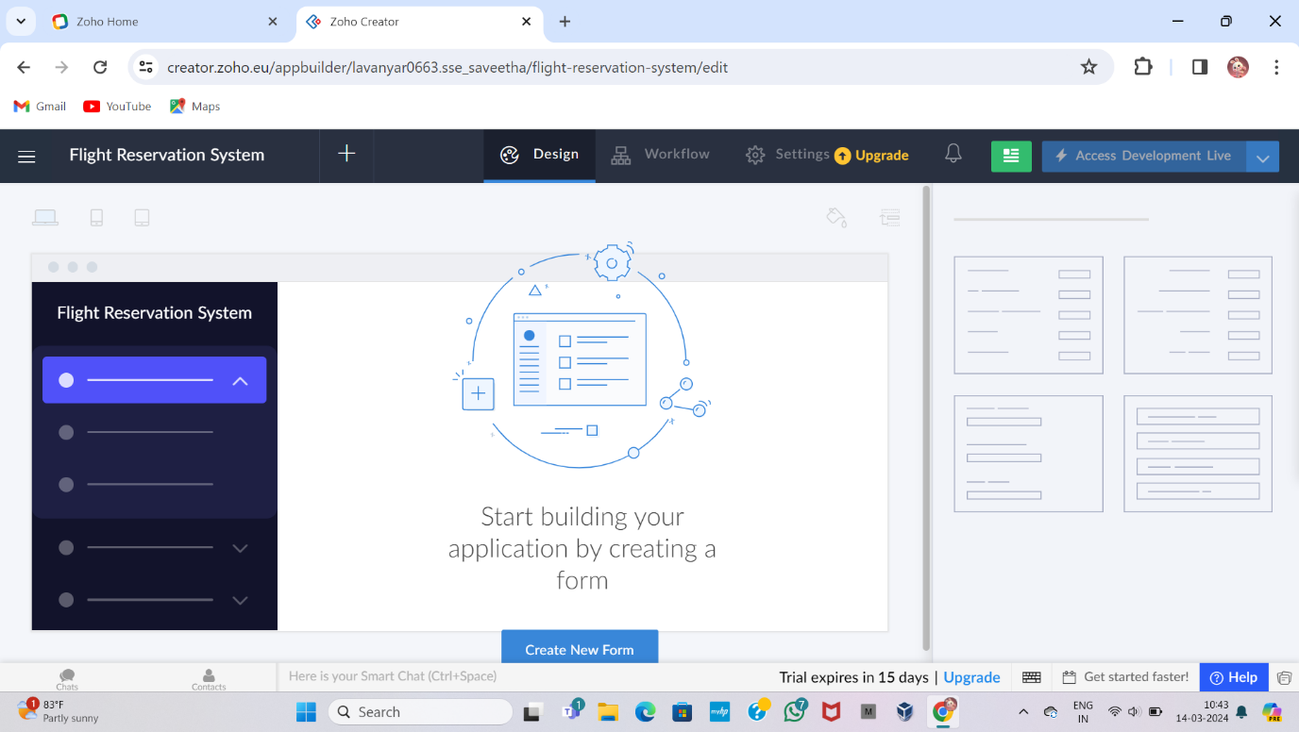

STEP -2: To create a form for Passenger Details

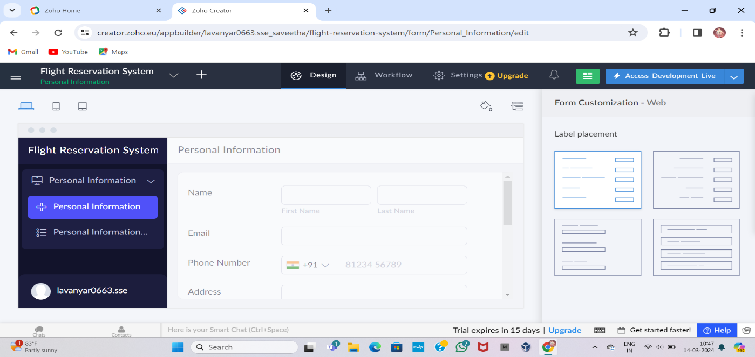

STEP -3: To create a form for Journey Details

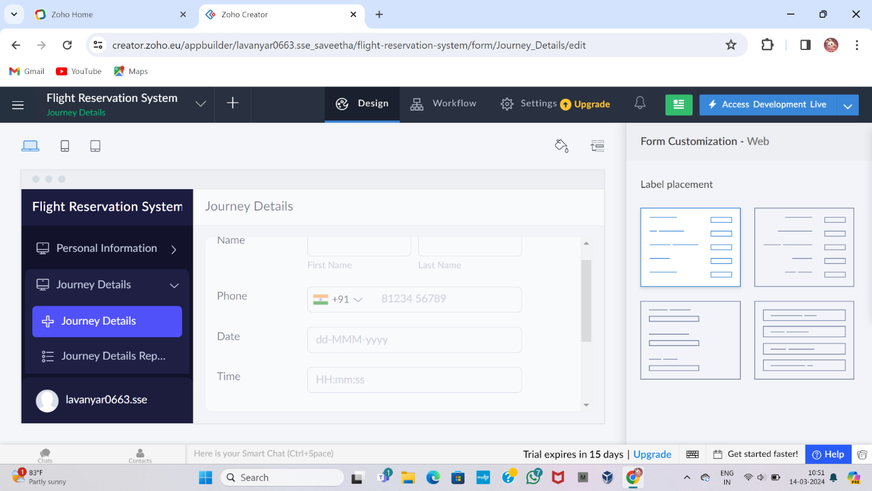

STEP -4: To create a form for Flight Details

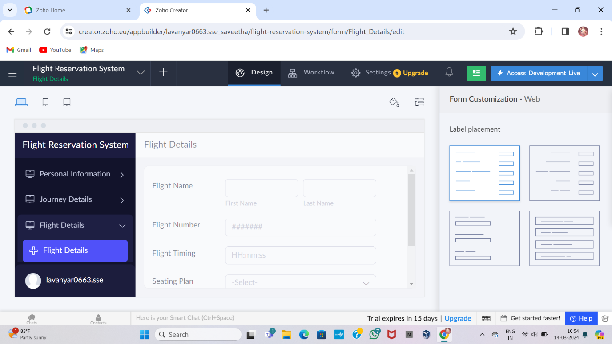

STEP -5: To Display the Details of the Passengers

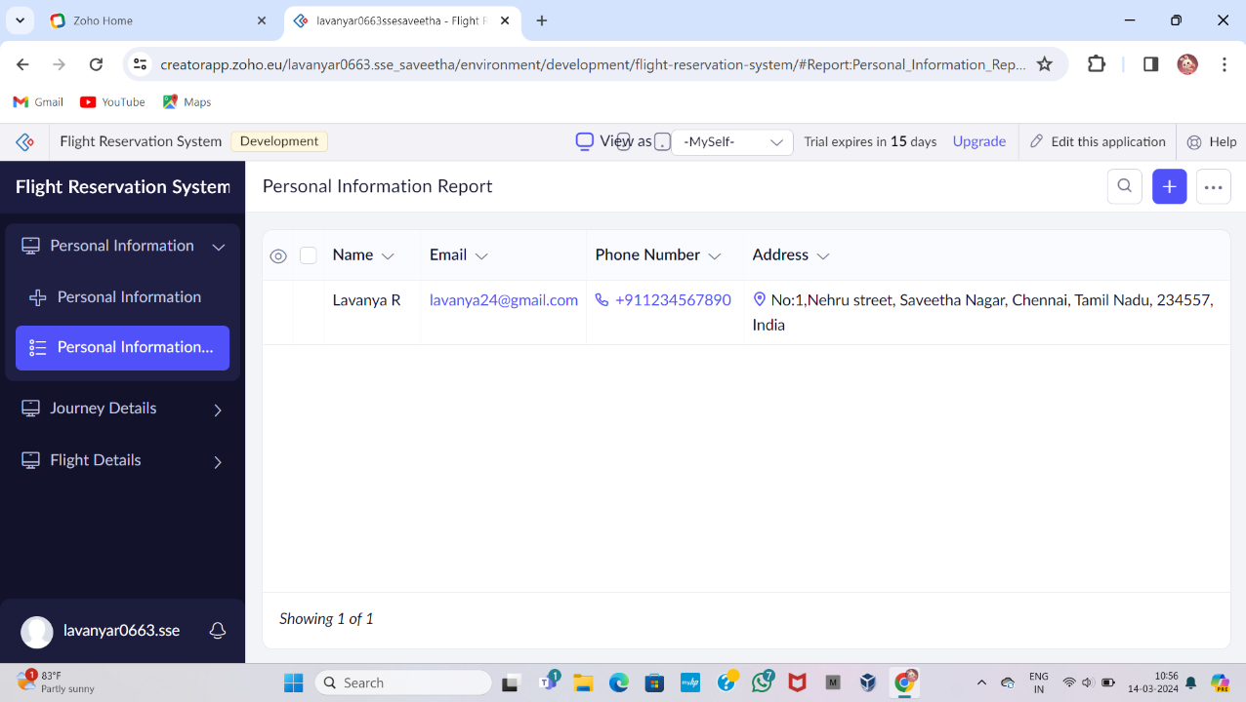

STEP -6: To Display the Details of the Journey

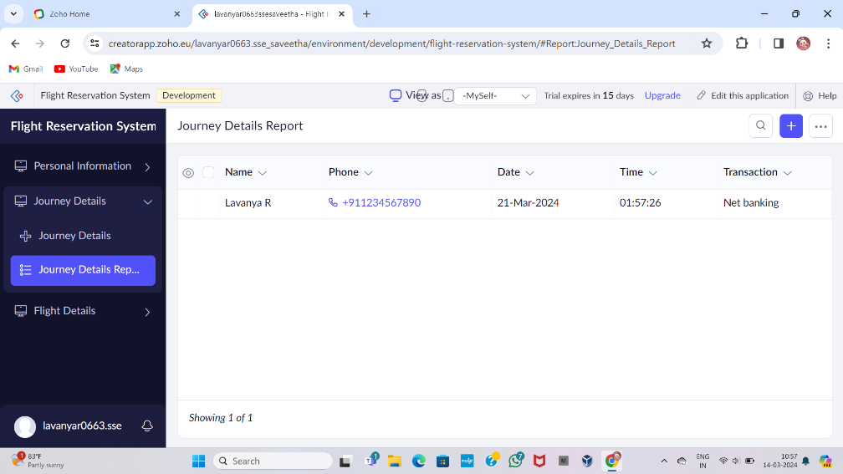

STEP -7: To Display the Details of the Flight Details

